Antarctica
Geography
Antarctica is the World's fifth-largest continent measuring approximately 14 million km², covering approximately 8.9% of the Earth's land and 2.7% of the Earth's surface.
It is surrounded by the Southern Ocean and lies almost entirely within the Antarctic circle.
98% of the land area is permanently covered with ice.
The Eastern side of Antarctica is higher than the West. The highest point is Vinson Massif measuring 4,897 m.
Climate
Antarctica is the coldest place on Earth. The higher, eastern side of Antarctica is colder than the lower west and the peninsula of Graham Land is the warmest region.
Winter temperatures are between -80°C and -90°C while summer temperatures range between +5°C and 15°C.
Antarctica is also one of the windiest places on Earth and the strong winds add a chill factor to the severely low temperatures.
There is very little rainfall even in the warmer peninsula area. Average rainfall measures less than 10cm per year.
Heavy snowfalls are common and can measure as much as 1.2 m in 48 hours.
Countries
There are no countries in Antarctica but various regions have been named.
Demography
There is no native population, but during the warmer summer months scientists man weather and research stations around the continent.

Plant Life
Because of the extreme cold the only plant life to be found on Antarctica are mosses and lichen.
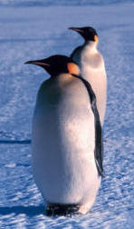
Animal Life
The only land animals to be found on Antarctica are invertebrates such as mites and lice. The lack of vegetation makes it impossible for other land animals to survive the harsh conditions.
The majority of mammals found on or in the seas
surrounding Antarctica are marine species such as seals, orcas and whales.
Antarctica is home to many species of penguins including the Emperor Penguin which is the only species to breed in the winter months.

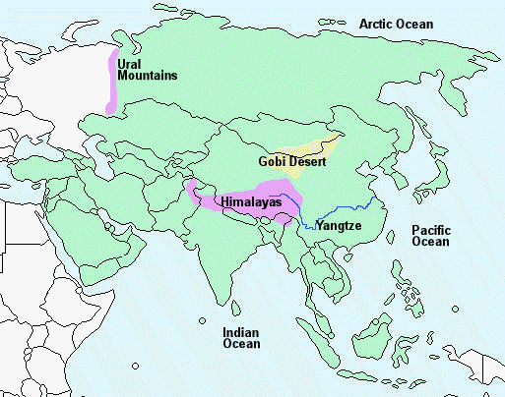

Asia
Geography
Asia is the World's largest continent - 43,810,582 km². covering approximately 30% of the Earth's land and 8.66% of the Earth's surface.
It is bordered by the Ural Mountains to the east, the Arctic Ocean to the north, the Pacific Ocean to the west and the Indian Ocean to the south.

The highest point in the World, is Mount Everest (8,848 m), situated in the Tibetan region of the Himalayas.
The longest river in Asia and third longest in the World is the Yangtze (6,211 km) which flows through China.
The largest desert in Asia is the Gobi desert measuring 281,800 km².
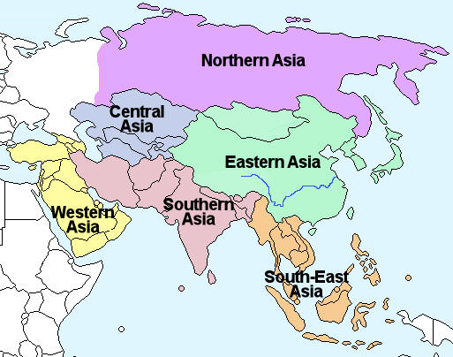
Regions & Seasons
Asia is broadly divided into six regions as shown on the map left.
Asia lies almost entirely in the northern hemisphe re and the seasons of all are similar. The seasons of southern and south-east Asia vary slightly because of the monsoons.

Northern Asia, Central Asia, Eastern Asia
- Spring - March, April, May
- Summer - June, July, August
- Autumn - September, October, November
- Winter - December, January, February
Southern Asia, South-East Asia
- Spring - December, January, February
- Summer - March, April, May
- Autumn - June, July, August
- Winter - September, October, November

Climate
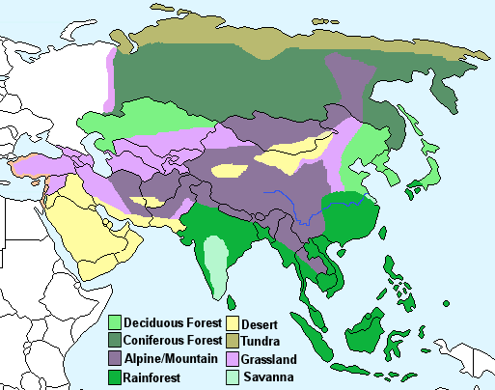
The climate of Asia varies according to location and physical geography. There are eight different climate types:
Deciduous forest - Four distinct seasons with warm summers and cold, wet winters. The trees shed their leaves in autumn.
Coniferous forest - Also known as Taiga, cold and dry with snowy winters and warmer summers.
Alpine/mountain - Cold, windy and snowy. It is winter from October to May with temperatures below freezing, while summer is from June to September where the temperature can reach 15°C.

Rainforest - High temperatures and high rainfall throughout the year.
Desert - Warm to high temperatures with very little rainfall.
Tundra - This area is characterised by a layer of permafrost (soil that has remained below freezing for at least two years. Winters are very cold, summers are warm and there is little rainfall.
Grassland - Hot summers and cold winters with above average rainfall.
Savanna - Very high temperatures all year and rain during the summer season only.
Countries
There are 53 countries in Asia including Russia and Turkey which lie in both Europe and Asia and Taiwan which is technically a part of China and not officially recognised as a country by the United Nations.
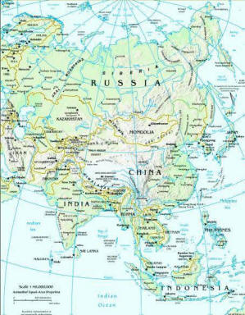
Afghanistan, Armenia, Azerbaijan, Bahrain, Bangladesh, Bhutan, Brunei, Cambodia, China, Georgia, Hong Kong, India, Indonesia, Iran, Iraq, Israel, Japan, Jordan, Kazakhstan, North Korea, South Korea, Kuwait, Kyrgyzstan, Laos, Lebanon, Macau, Maldives, Malaysia, Maldives, Mongolia, Myanmar, Nepal, Oman, Pakistan, Palestine, Philippines, Qatar, Russia, Saudi Arabia, Singapore, Sri Lanka, Syria, Taiwan, Tajikistan, Timor-Leste, Turkey, Turkmenistan, United Arab Emirates, Uzbekistan, Vietnam, Yemen.
Demography
Asia is the most populated continent containing around 60% of the World's population. The population of Asia is growing with a growth rate of approximately 2%.

The total population of Asia is approximately 3,879,000,000 (2005). Eastern, southern and south-east Asia are the most populated while the desert, mountain and tundra regions are the least populated.
The countries with the highest populations (to the nearest million) are:
China - 1,384 million
India - 1,046 million
Indonesia - 227 million
Bangladesh - 133 million
Japan - 127 million
China, India and Japan are the most economically developed countries. The large oil producing nations - Iran, Iraq, Kuwait, Qatar, Saudi Arabia and the United Arab Emirates are also in Asia.
Economic growth in Asia has improved living standards for millions of people, but there remains a huge poverty problem and the gap between rich and poor is growing. According to World data records around 60% of the world's poorest people live in Asia.
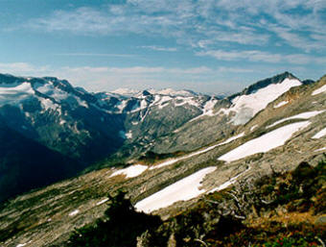
Plant Life
The plant life of Asia is wide and varied and differs according to climatic region.
Due to the cold during the winter months, only short grasses and shrubs can survive in the tundra and alpine/mountain regions. The picture (left) shows an alpine/mountain region.
The desert regions are home to those plants that can survive the arid conditions like cactii.
The coniferous forest region contains trees such as pine, fir and spruce.
The deciduous forest region has a wealth of plant life and includes tall and short trees, shrubs, small plants and mosses

The grassland and savanna regions are characterised by large open areas of tall or short grass.
The rainforest areas are jungles of dense, wet forests.
Animal Life
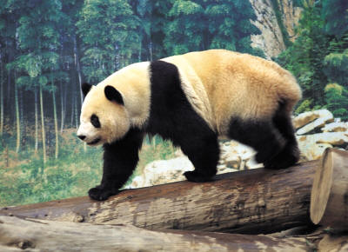
The animal life of Asia is wide and varied depending on the climatic region.
The tundra is home to reindeer, foxes and wolves, while camels and lizards can be found in the desert region.
Bears can be found in the coniferous forest region while the mountainous region of China is home to the giant panda.

Africa
Geography
Africa is the World's second-largest continent - 30,065,000 km² covering approximately 20% of the Earth's land and 6% of the Earth's surface .
It is bordered by the Atlantic Ocean to the east, the Indian Ocean to the west and the Mediterranean Sea to the north. The Red Sea and Suez Canal lie to the north-east and separate Africa from Asia.
The longest river in the World, The Nile, measuring 6,695 km - flows north ending in a delta that empties into the Mediterranean Sea.
The World's largest desert, The Sahara, measuring 9,000,000 km², covers much of north Africa. The Kalahari desert in south-west Africa measures 259,000 km².
The Atlas mountain range lies in the north-west of Africa and the highest mountain, Kilimanjaro, 5895 m, is in Tanzania.

Regions & Seasons
Africa is broadly divided into five regions as shown on the map right.
The seasons are fairly well defined in those regions that lie in the northern and southern hemispheres - the north and south of Africa.
Northern Africa - Spring - March, April, May
- Summer - June, July, August
- Autumn - September, October, November
- Winter - December, January, February

Southern Africa - Spring - August, September, October
- Summer - November, December, January
- Autumn - February, March, April
- Winter - May, June, July
The seasons of western, central and eastern Africa are less easy to define since these regions lie between the tropics of Cancer and Capricorn and tend to have a more constant temperature range throughout the year.
Climate
The climate of Africa is governed by its position on the globe and can be broadly divided into five different climate types:
Rainforest - This region is characterised by very high temperatures and high rainfall throughout the year.
Savanna - This region has very high temperatures all year and rain during the summer season only.
Steppe - This region has high temperatures all year and only limited rainfall during the summer season.
Desert - High temperatures throughout the year with very little rainfall.
Mediterranean - Warm to high temperatures with rainfall in the autumn and winter months.

Countries
There are 53 countries in Africa
Algeria, Angola, Benin, Botswana, Burkina Faso, Burundi, Cameroon, Cape Verde, Central African Republic, Chad, Comoros, Congo, Congo (DRC), Cote d'Ivoire, Djibouti, Egypt, Equatorial Guinea, Eritrea, Ethiopia, Gabon, Gambia, Ghana, Guinea, Guinea-Bissau, Kenya, Lesotho, Liberia, Libya, Madagascar, Malawi, Mali, Mauritania, Mauritius, Morocco, Mozambique, Namibia, Niger, Nigeria, Rwanda, Sao Tome & Principe, Senegal, Seychelles, Sierra Leone, Somalia, South Africa, Sudan, Swaziland, Tanzania, Togo, Tunisia, Uganda, Western Sahara, Zambia, Zimbabwe..
DemographyThe population of Africa is growing rapidly with a growth rate of approximately 3% per annum.
The total population of Africa is approximately 877,500,000 (2005). The desert regions are the least populated while the most populated areas are in the north, south and around the Gulf of Guinea.
The countries with the highest populations (to the nearest million) are:
Nigeria - 130 million
Egypt - 71 million
Ethiopia - 68 million
Democratic Republic of Congo - 55 million
South Africa - 44 million
Botswana and South Africa are the most economically developed regions while Nigeria is Africa's largest oil producing region.
About 70% of Africa's population rely on agriculture for income and times of drought can produce severe hardship. The climate of Africa together with the effects of the Slave Trade, colonisation, international trade and internal wars and conflicts make Africa the World's poorest continent.
Plant Life
The plant life of Africa is wide and varied and differs according to climatic region.
The desert regions are home to those plants that can survive the arid conditions and include varieties of cypress, olive trees and cactii.
The steppe and savanna regions are characterised by large open areas of tall grass like that shown in the picture (left).

The rainforest areas are jungles of dense, wet forests.
Animal Life
The grassland areas of Africa are home to many well known wild animals including - aardvark, African elephant, antelope, baboon, buffalo, cheetah, giraffe, gnu, hippopotamus, hyena, impala, jackal, leopard, lion, meerkat, mongoose, ostrich, rhinoceros, vulture, wildebeest and zebra.
The rainforest areas are home to a wide variety of insects, birds and animals including - antelope, chimpanzee, gorilla, Mandrill, okapi, hippopotamus and parrots parrots.

Australasia/Oceania
Geography
Australasia, also called Oceania or Australasia/Oceania, is the World's smallest continent - 8,112,000 km² covering approximately 5.3% of the Earth's land and 1.5% of the Earth's surface.
It is situated partly in the Pacific ocean, bordered by the Indian Ocean to the west and the Southern ocean to the south.
The highest point is Mount Wilhelm (4509 m) in Papua New Guinea.
The longest river is the Darling river (2,739 km) which is a tributary of the Murray river in Australia.
Australasia is the flattest continent with much of Australia being desert.

Regions & Seasons
Australasia/Oceania is broadly divided into four regions as shown on the map right.
Australasia lies entirely in the southern hemisphere and the seasons of all are similar.
- Spring - September, October, November
- Summer - December, January, February
- Autumn - March, April, May
- Winter - June, July, August
Climate
The climate of Australasia/Oceania can be divided into six different climate types
Deciduous forest - Four distinct seasons with warm summers and cold, wet winters. The trees shed their leaves in autumn.
Rainforest - High temperatures throughout the year with very little rainfall.
Savanna - Very high temperatures all year and rain during the summer season only.

Desert - Warm to high temperatures with very little rainfall.
Desert scrub - Hot summers and cold winters with above average rainfall.

Countries and Islands
There are 28 countries and Island groups in Australasia/Oceania

Australia, Christmas Island, Cocos Islands, Cook Islands, Fiji, Guam, Kiribati, Marshall Islands, Federated States of Micronesia, Nauru, New Caledonia, New Zealand, Niue, Norfolk Island, Northern Mariana Islands, Palau, Papua New Guinea, Pitcairn Islands, French Polynesia, American Samoa, Samoa, Solomon Islands, Tokelau, Tonga, Tuvalu, Vanuatu, Wallis and Futuna
DemographyAustralasia/Oceania is the least populated continent after Antarctica. It contains around 0.5% of the World's population with a growth rate of approximately 1.3% per year.
The total population of Australasia is around 32,000,000 (2005). Eastern and south-eastern Australia, northern New Zealand and the Pacific islands are the most populated while the desert region of Australia is the least populated.
The countries with the highest populations (to the nearest million) are:
Australia - 20 million
Papua New Guinea - 5 million
New Zealand - 4 million
Fiji - 1 million
Australia and New Zealand are the most economically developed countries.
Plant Life
The plant life of Australasia is wide and varied and in some cases unique to the continent.
The tropical island regions are home to dense forests with coconut palms and mangroves growing nearer the shorelines.
The dry desert and desert scrub region of Australia is home to the eucalyptus as well as those plants that can survive the arid conditions like cactii.
The deciduous forest region has a wealth of plant life and includes tall and short trees, shrubs, small plants and mosses

Animal Life
The animal life of Australasia is wide and varied and in many cases unique to the continent.
Marsupials such as kangaroos, possums and wombats can be found in Australia and Papua New Guinea.
Many of the Pacific islands are the unique home of lizards and geckos.
Other animals that can be found in Australasia include koalas, dingoes, crocodiles, monitor lizards and komodo dragons.
Birds are a common feature of the Pacific islands while emus, kiwis, and cockatoos are all native to Australasia.

Europe
Geography
Europe is the World's second-smallest continent - 10,180,000 km² covering approximately 6.7% of the Earth's land and 2% of the Earth's surface .
It is bordered by the Atlantic Ocean to the west, the Arctic Ocean to the north and the Mediterranean Sea to the south. The Ural mountains in Russia mark the eastern extreme.
The southern regions are higher and include the Pyrenees, the Alps and the Carpathian mountain ranges.
The longest river in Europe is the Volga (2,850 km) in Russia.
The highest mountain is Elbrus (5,642 m) in Russia.
Regions & Seasons
Europe regions
European Union Europe can be broadly divided into three regions as shown on the map left.

Europe can also be divided according to European Union member states and non-member states as shown on the map right.

Europe lies entirely in the Northern hemisphere and has four distinct seasons
- Spring - March, April, May
- Summer - June, July, August
- Autumn - September, October, November
- Winter - December, January, February

Climate
The climate of Europe can be broadly divided into five different climate types:
Deciduous forest - Four distinct seasons with warm summers and cold, wet winters. The trees shed their l leaves in autumn.
Coniferous forest - Also known as Taiga, cold and dry with snowy winters and warmer summers.

Mediterranean - Warm to high temperatures with rainfall in the autumn and winter months.
Grassland - Hot summers and cold winters with above average rainfall.
Tundra - This area is characterised by a layer of permafrost (soil that has remained below freezing for at least two years. Winters are very cold, summers are warm and there is little rainfall.

Countries

There are 47 countries in Europe including Turkey and Russia which lie in both Europe and Asia.

Albania, Andorra, Austria, Belarus, Belgium, Bosnia and Herzegovina, Bulgaria, Croatia, Cyprus, Czech Republic, Denmark, Estonia, Finland, France, Germany, Greece, Hungary, Iceland, Ireland, Italy, Latvia, Liechtenstein, Lithuania, Luxembourg, Macedonia, Malta, Moldova, Monaco, Montenegro, Netherlands, Norway, Poland, Portugal, Romania, Russia, San Marino, Serbia, Slovakia, Slovenia, Spain, Sweden, Switzerland, Turkey, Ukraine, United Kingdom, Vatican City.

Demography
Europe is the third most populated continent with a total population of around 729,000,000 (2006) about 11% of the World's population. Southern England, western Germany, the Netherlands and northern Italy are the most populated areas while Iceland, northern Scandinavia and northern Russia are the least populated.
The countries with the highest populations (to the nearest million) are:
Russia - 106 million
Germany - 83 million
United Kingdom - 60 million
France - 60 million
Italy - 60 million

Europe has the largest economy of the world with Germany and the United Kingdom being the most economically developed countries.
The countries of central and eastern Europe are the least economically developed and are poorer in relation to the western countries.
Plant Life

The plant life of Europe is characterised according to climatic region.
The deciduous forest region has a wealth of plant life and includes tall and short trees, shrubs, small plants and mosses. The picture (left) shows a deciduous forest region of Hungary.
The coniferous forest region contains trees such as pine, fir and spruce.
Due to the cold during the winter months, only short grasses and shrubs can survive in the tundra region.
The grassland region is characterised by large open areas of tall or short grass.
Plants found in the Mediterranean region have adapted to the differences in rainfall and temperature between winter and summer and include, palm trees, citrus trees, forest and scrub.

Animal Life
Due to the density of population in Europe there are few areas of natural habitat remaining and many indigenous animals are now extinct or in danger of extinction.
Brown bears and wolves can be found in the northern coniferous forest regions.
Deer, foxes, hedgehogs, snakes and wild cats can be found in the deciduous forest regions.

North America
Geography
North America is the World's third-largest continent - 24,474,000 km² covering approximately 16.5% of the Earth's land and 5% of the Earth's surface.
It is bordered by the Atlantic Ocean to the east, the Arctic Ocean to the north and the Pacific Ocean to the west.
The eastern side of the continent is generally lower than the west which contains the Rocky mountains. The five Great Lakes lie on the United States Canadian border.
The highest mountain is Mt McKinley in Alaska (6,194 m) and the longest river is the Mississippi (3,765 km).
Regions & Seasons
North America regions North America can be broadly divided into the six regions shown on the map (right).
Greenland, Canada and most of the United States lie in the Northern hemisphere and have four distinct seasons
- Spring - March, April, May
- Summer - June, July, August
- Autumn - September, October, November
- Winter - December, January, February

Mexico, Central America, the Caribbean and southern United States have more constant temperatures throughout the year but have a wet season - May to October and a dry season - November to April.

Climate
The climate of North America can be broadly divided into eight different climate types:
Deciduous forest - Four distinct seasons with warm summers and cold, wet winters. The trees shed their leaves in autumn.
Coniferous forest - Also known as Taiga, cold and dry with snowy winters and warmer summers.
Mediterranean - Warm to high temperatures with rainfall in the autumn and winter months.
Grassland - Hot summers and cold winters with above average rainfall.
Tundra - This area is characterised by a layer of permafrost (soil that has remained below freezing for at least two years. Winters are very cold, summers are warm and there is little rainfall.
Alpine/mountain - Cold, windy and snowy. It is winter from October to May with temperatures below freezing, while summer is from June to September where the temperature can reach 15°C.
Rainforest - High temperatures and high rainfall throughout the year.
Desert - Warm to high temperatures with very little rainfall.
Countries
There are 38 countries and Islands in North America.

Anguilla, Antigua and Barbuda, Aruba, The Bahamas, Barbados, Belize, Bermuda, British Virgin Islands, Canada, Cayman Islands, Costa Rica, Cuba, Dominica, Dominican Republic, El Salvador, Greenland, Grenada, Guadeloupe, Guatemala, Haiti, Honduras, Jamaica, Martinique, Mexico, Montserrat, Navassa Islands, Netherlands An tilles, Nicaragua, Panama, Puerto Rico, Saint Kitts and Nevis, Saint Lucia, Saint-Pierre and Miquelon, Saint Vincent and the Grenadines, Trinidad and Tobago, United States of America, US Virgin Islands.
Demography
North America is the fourth most populated continent with a total population of around 520,000,000 (2005) about 5.5% of the World's population. Eastern United States, Mexico, Central America and the Caribbean are the most densely populated areas while Canada, Alaska and Greenland are the least populated areas. The countries with the highest populations (to the nearest million) are:
Unites States - 300 million
Mexico - 106 million
Canada - 33 million
Guatemala - 15 million
Cuba - 11 million
The United States and Canada are the most economically developed countries. The countries of central America and the Caribbean are less economically developed and poorer.
Plant Life
The plant life of North America is characterised according to climatic region.
The deciduous forest region has a wealth of plant life and includes tall and short trees, shrubs, small plants and mosses.
The coniferous forest region contains trees such as pine, fir and spruce. The picture (left) shows a coniferous forest in northern California.
Due to the cold during the winter months, only short grasses and shrubs can survive in the tundra and alpine/mountain regions.

The grassland region is characterised by large open areas of tall or short grass.
Plants found in the Mediterranean region have adapted to the differences in rainfall and temperature between winter and summer and include, palm trees, citrus trees, forest and scrub.
The rainforest areas are jungles of dense, wet forests.
The desert regions are home to those plants that can survive the arid conditions and include varieties of cactii.
Animal Life
North America is home to a range of wild animals including the bobcat , sea otter, racoon and the mountain lion.
Polar bears, wolves and caribou live in the arctic regions of Canada and Greenland.

South America
Geography
South America is the World's fourth-largest continent - 17,840,000 km² covering approximately 12% of the Earth's land and 3.5% of the Earth's surface.
It is bordered by the Atlantic Ocean to the east and the Pacific Ocean to the west.
The eastern side of the continent is generally lower than the west which contains the Andes mountain range.
The second-longest river in the World, the Amazon (6,400 km) flows across the top of the continent.

Argentina is home to the highest mountain Aconcagua (6960 m) and the World's highest waterfall - Angel Falls (979 m).
Regions & Seasons
South America is not divided into regions.
South America is located in the southern hemisphere. Those countries to the south of the continent have four distinct seasons.
- Spring - September, October, November
- Summer - December, January, February
- Autumn - March, April, May
- Winter - June, July, August
The countries in the north of the continent have more constant high temperatures and high rainfall throughout the year.
Climate
The climate of South America can be broadly divided into seven different climate types:
Desert - Warm to high temperatures with very little rainfall.
Grassland - Hot summers and cold winters with above average rainfall.
Deciduous forest - Four distinct seasons with warm summers and cold, wet winters. The trees shed their leaves in autumn.
Rainforest - High temperatures and high rainfall throughout the year.
Savanna - This region has very high temperatures all year and rain during the summer season only.
Mediterranean - Warm to high temperatures with rainfall in the autumn and winter months.

Alpine/mountain - Cold, windy and snowy. It is winter from October to May with temperatures below freezing, while summer is from June to September where the temperature can reach 15°C.
Countries
There are 16 countries and Islands in South America.
Argentina, Bolivia, Brazil, Chile, Colombia, Ecuador, Falkland Islands, French Guiana, Guyana, Paraguay, Peru, South Georgia and South Sandwich Islands, Suriname, Uruguay, Venezuela.

Demography
South America is the fifth most populated continent with a total population of around 371,000,000 (2005). The north-west coastal region and the eastern coast of Brazil are the most densely populated areas while the Amazon rainforest area is the least populated. The countries with the highest populations (to the nearest million) are:
Brazil - 188 million
Colombia - 43 million
Argentina - 40 million
Peru - 28 million
Venezuela - 26 million
Brazil is the most economically developed country but the economies of Argentina, Venezuela, Peru and Uruguay are growing the most quickly. Throughout South America there is a wide gap between the rich and poor.

Plant Life
The plant life of South America is characterised according to climatic region.
The rainforest areas are jungles of dense, wet forests. The picture (left) shows an area of the Amazon Rainforest.
The desert regions are home to those plants that can survive the arid conditions and include varieties of cactii.
The deciduous forest region has a wealth of plant life and includes tall and short trees, shrubs, small plants and mosses.
Due to the cold during the winter months, only short grasses and shrubs can survive in the alpine/mountain region.
The grassland and savanna regions are characterised by large open areas of tall or short grass.
Plants found in the Mediterranean region have adapted to the differences in rainfall and temperature between winter and summer and include, palm trees, citrus trees, forest and scrub.

Animal Life
South America is home to many species of animals including llama, anaconda, pirana, jaguar, vicuna, and tapir

